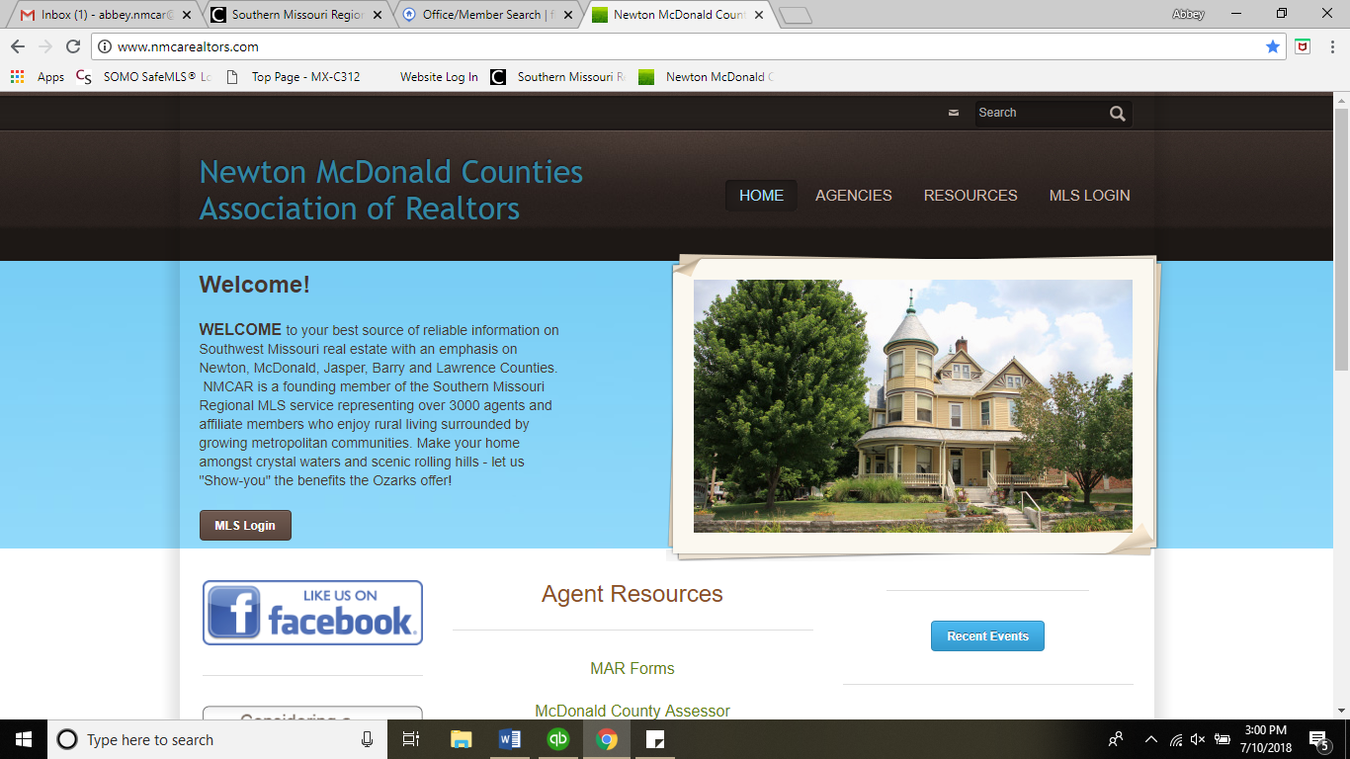

**FOUR**

**CORNERS REALTORS®**

238 S. Neosho Blvd.

P.O. BOX 1101

NEOSHO, MO 64850

417-456-9699

417-850-0599

**2023 Board of Directors**

**President**

**Lisa Wilson**

**417-529-2130**

**Vice President**

**Leigh Ann DuParri**

**417-846-5863**

**Secretary/ Treasurer**

**Susan Forbes**

**417-389-2691**

**Board member 3yr term**

**Daniel Forbes**

**417-389-2692**

**Board member 2yr term**

**Melissa Gibbens**

**417-540-1627**

**Board member 1yr term**

**Sally Bush**

**417-437-3174**

**A.E Shawna Whorton**

**State Directors**

**-Ben Davis**

**SWMO Homes**